ROY KIPLAGAT KOECH

ADM NO: 1062586

CMT 208

INTRODUCTION TO ARTIFICIAL INTELLIGENCE

Assignment

1. History of artificial intelligence

AI began in the early 1900s. And although the biggest strides weren’t made until the 1950s, it wouldn’t have been possible without the work of early experts in many different fields. Knowing the history of AI is important in understanding where AI is now and where it may go in the future.

Groundwork for AI:

1900-1950In the early 1900s, there was a lot of media created that centered around the idea of artificial humans. So much so that scientists of all sorts started asking the question: is it possible to create an artificial brain? Some creators even made some versions of what we now call “robots” (and the word was coined in a Czech play in 1921) though most of them were relatively simple. These were steam-powered for the most part, and some could make facial expressions and even walk.

Dates of note:

* **1921:** Czech playwright Karel Čapek released a science fiction play “[Rossum’s Universal Robots](https://www.gutenberg.org/files/59112/59112-h/59112-h.htm)” which introduced the idea of “artificial people” which he named robots. This was the first known use of the word.
* **1929:** Japanese professor Makoto Nishimura built the first Japanese robot, named [Gakutensoku](https://spectrum.ieee.org/the-short-strange-life-of-the-first-friendly-robot" \l "toggle-gdpr).
* **1949:** Computer scientist Edmund Callis Berkley published the book “[Giant Brains, or Machines that Think](https://monoskop.org/images/b/bc/Berkeley_Edmund_Callis_Giant_Brains_or_Machines_That_Think.pdf)” which compared the newer models of computers to human brains.

Birth of AI: 1950-1956

This range of time was when the interest in AI really came to a head. Alan Turing published his work “Computer Machinery and Intelligence” which eventually became The Turing Test, which experts used to measure computer intelligence. The term “artificial intelligence” was coined and came into popular use.

Dates of note:

* **1950:** Alan Turing published “[Computer Machinery and Intelligence](https://academic.oup.com/mind/article/LIX/236/433/986238)” which proposed a test of machine intelligence called The Imitation Game.
* **1952:** A computer scientist named [Arthur Samuel](https://history.computer.org/pioneers/samuel.html) developed a program to play checkers, which is the first to ever learn the game independently.
* **1955:**[John McCarthy](https://computerhistory.org/profile/john-mccarthy/" \l ":~:text=McCarthy%20coined%20the%20term%20%E2%80%9CAI,programming%20language%20lisp%20in%201958.) held a workshop at Dartmouth on “artificial intelligence” which is the first use of the word, and how it came into popular usage.

AI maturation: 1957-1979

The time between when the phrase “artificial intelligence” was created, and the 1980s was a period of both rapid growth and struggle for AI research. The late 1950s through the 1960s was a time of creation. From programming languages that are still in use to this day to books and films that explored the idea of robots, AI became a mainstream idea quickly.

The 1970s showed similar improvements, such as the first anthropomorphic robot being built in Japan, to the first example of an autonomous vehicle being built by an engineering grad student. However, it was also a time of struggle for AI research, as the U.S. government showed little interest in continuing to fund AI research.

Notable dates include:

* **1958:** John McCarthy created [LISP](https://www.britannica.com/technology/LISP-computer-language) (acronym for List Processing), the first programming language for AI research, which is still in popular use to this day.
* **1959:** [Arthur Samuel created the term “machine learning”](http://infolab.stanford.edu/pub/voy/museum/samuel.html) when doing a speech about teaching machines to play chess better than the humans who programmed them.
* **1961:** The first industrial robot [Unimate](https://robots.ieee.org/robots/unimate/) started working on an assembly line at General Motors in New Jersey, tasked with transporting die casings and welding parts on cars (which was deemed too dangerous for humans).
* **1965:** Edward Feigenbaum and Joshua Lederberg created [the first “expert system”](https://www.computer.org/profiles/edward-feigenbaum) which was a form of AI programmed to replicate the thinking and decision-making abilities of human experts.
* **1966:** Joseph Weizenbaum created the first “chatterbot” (later shortened to chatbot), [ELIZA, a mock psychotherapist](https://analyticsindiamag.com/story-eliza-first-chatbot-developed-1966/), that used natural language processing (NLP) to converse with humans.1968: Soviet mathematician Alexey Ivakhnenko published “Group Method of Data Handling” in the journal “Avtomatika,” which proposed a new approach to AI that would later become what we now know as “Deep Learning.”
* **1973:** An applied mathematician named [James Lighthill](https://www.britannica.com/biography/James-Lighthill) gave a report to the British Science Council, underlining that strides were not as impressive as those that had been promised by scientists, which led to much-reduced support and funding for AI research from the British government.
* **1979:** James L. Adams created [The Standford Cart](https://web.stanford.edu/~learnest/sail/oldcart.html) in 1961, which became one of the first examples of an autonomous vehicle. In ‘79, it successfully navigated a room full of chairs without human interference.
* **1979:** The American Association of Artificial Intelligence which is now known as the [Association for the Advancement of Artificial Intelligence](http://aaai.org/) (AAAI) was founded.

AI boom: 1980-1987

Most of the 1980s showed a period of rapid growth and interest in AI, now labeled as the “AI boom.” This came from both breakthroughs in research, and additional government funding to support the researchers. Deep Learning techniques and the use of Expert System became more popular, both of which allowed computers to learn from their mistakes and make independent decisions.

Notable dates in this time period include:

* **1980:** First conference of the AAAI was held at Stanford.
* **1980:** The [first expert system came into the commercial market](https://dbpedia.org/page/Xcon), known as XCON (expert configurer). It was designed to assist in the ordering of computer systems by automatically picking components based on the customer’s needs.
* **1981:** The Japanese government allocated $850 million (over $2 billion dollars in today’s money) to the [Fifth Generation Computer project](https://dl.acm.org/doi/pdf/10.1145/1067651.801682). Their aim was to create computers that could translate, converse in human language, and express reasoning on a human level.
* **1984:** The AAAI warns of an incoming “[AI Winter](https://towardsdatascience.com/history-of-the-first-ai-winter-6f8c2186f80b)” where funding and interest would decrease, and make research significantly more difficult.
* **1985:** An autonomous drawing program known as [AARON](https://computerhistory.org/blog/harold-cohen-and-aaron-a-40-year-collaboration/) is demonstrated at the AAAI conference.
* **1986:** Ernst Dickmann and his team at Bundeswehr University of Munich created and demonstrated the [first driverless car](https://www.politico.eu/article/delf-driving-car-born-1986-ernst-dickmanns-mercedes/) (or robot car). It could drive up to 55 mph on roads that didn’t have other obstacles or human drivers.
* **1987:** Commercial launch of Alacrity by Alactrious Inc. Alacrity was the first strategy managerial advisory system, and used a complex expert system with 3,000+ rules.

AI winter: 1987-1993

As the AAAI warned, an AI Winter came. The term describes a period of low consumer, public, and private interest in AI which leads to decreased research funding, which, in turn, leads to few breakthroughs. Both private investors and the government lost interest in AI and halted their funding due to high cost versus seemingly low return. This AI Winter came about because of some setbacks in the machine market and expert systems, including the end of the Fifth Generation project, cutbacks in strategic computing initiatives, and a slowdown in the deployment of expert systems.

Notable dates include:

* **1987:** The [market for specialized LISP-based hardware collapsed](https://www.federalreserve.gov/pubs/feds/2007/200713/200713pap.pdf) due to cheaper and more accessible competitors that could run LISP software, including those offered by IBM and Apple. This caused many specialized LISP companies to fail as the technology was now easily accessible.
* **1988:**A computer programmer named [Rollo Carpenter invented the chatbot Jabberwacky](https://www.yourtechstory.com/2019/11/13/success-story-of-cleverbot/), which he programmed to provide interesting and entertaining conversation to humans.

AI agents: 1993-2011

Despite the lack of funding during the AI Winter, the early 90s showed some impressive strides forward in AI research, including the introduction of the first AI system that could beat a reigning world champion chess player. This era also introduced AI into everyday life via innovations such as the first Roomba and the first commercially-available speech recognition software on Windows computers.

The surge in interest was followed by a surge in funding for research, which allowed even more progress to be made.

Notable dates include:

* **1997:** [Deep Blue](https://www.ibm.com/ibm/history/ibm100/us/en/icons/deepblue/) (developed by IBM) beat the world chess champion, Gary Kasparov, in a highly-publicized match, becoming the first program to beat a human chess champion.
* **1997:**Windows released a speech recognition software (developed by Dragon Systems).
* **2000:** Professor Cynthia Breazeal developed the first robot that could simulate human emotions with its face,which included eyes, eyebrows, ears, and a mouth. It was called Kismet.
* **2002:** The first Roomba was released.
* **2003:** [Nasa landed two rovers onto Mars](https://mars.nasa.gov/mars-exploration/missions/historical-log/) (Spirit and Opportunity) and they navigated the surface of the planet without human intervention.
* **2006:** Companies such as Twitter, Facebook, and Netflix started utilizing AI as a part of their advertising and user experience (UX) algorithms.
* **2010:** Microsoft launched the Xbox 360 Kinect, the first gaming hardware designed to track body movement and translate it into gaming directions.
* **2011:** An NLP computer programmed to answer questions named [Watson](https://www.ibm.com/ibm/history/ibm100/us/en/icons/watson/) (created by IBM) won Jeopardy against two former champions in a televised game.
* **2011:** Apple released Siri, the first popular virtual assistant.

Artificial General Intelligence: 2012-present

That brings us to the most recent developments in AI, up to the present day. We’ve seen a surge in common-use AI tools, such as virtual assistants, search engines, etc. This time period also popularized Deep Learning and Big Data..

Notable dates include:

* **2012:**Two researchers from Google (Jeff Dean and Andrew Ng) trained a neural network to recognize cats by showing it unlabeled images and no background information.
* **2015:** Elon Musk, Stephen Hawking, and Steve Wozniak (and over 3,000 others) signed an open letter to the worlds’ government systems banning the development of (and later, use of) autonomous weapons for purposes of war.
* **2016:** Hanson Robotics created a humanoid robot named Sophia, who became known as the first “robot citizen” and was the first robot created with a realistic human appearance and the ability to see and replicate emotions, as well as to communicate.
* **2017:** Facebook programmed two AI chatbots to converse and learn how to negotiate, but as they went back and forth they ended up forgoing English and developing their own language, completely autonomously.
* **2018:** A Chinese tech group called Alibaba’s language-processing AI beat human intellect on a Stanford reading and comprehension test.
* **2019:**Google’s AlphaStar reached Grandmaster on the video game StarCraft 2, outperforming all but .2% of human players.
* **2020:**OpenAI started beta testing GPT-3, a model that uses Deep Learning to create code, poetry, and other such language and writing tasks. While not the first of its kind, it is the first that creates content almost indistinguishable from those created by humans.
* **2021:** OpenAI developed DALL-E, which can process and understand images enough to produce accurate captions, moving AI one step closer to understanding the visual world.

1. Techniques of artificial intelligence

* Neural networks

A neural network is a method in artificial intelligence (AI) that teaches computers to process data in a way that is inspired by the human brain

They are powerful tools in machine learning that are modeled after the structure of the human brain

When you design an ANN, you will be compiling layers of interconnected nodes or "neurons" that process and transmit information, similar to the nerve cells in our brains. You can use artificial neural networks to recognize complex patterns, learn from changing sets of data, and make ongoing predictions in real time.

ANNs are mathematical models that use complex algorithms to determine the strength of each “neuron” and the strength of its relationship to each other neuron. An ANN uses the predicted and actual outputs to improve its function. Data scientists refer to this process as “training.”

You can utilize many different types of artificial neural network machine learning architectures, depending on your area of interest. Some common architectures include feedforward networks, recurrent networks, convolutional networks, and autoencoders. You can use each architecture for specific tasks, such as image classification, natural language processing, or time series prediction.

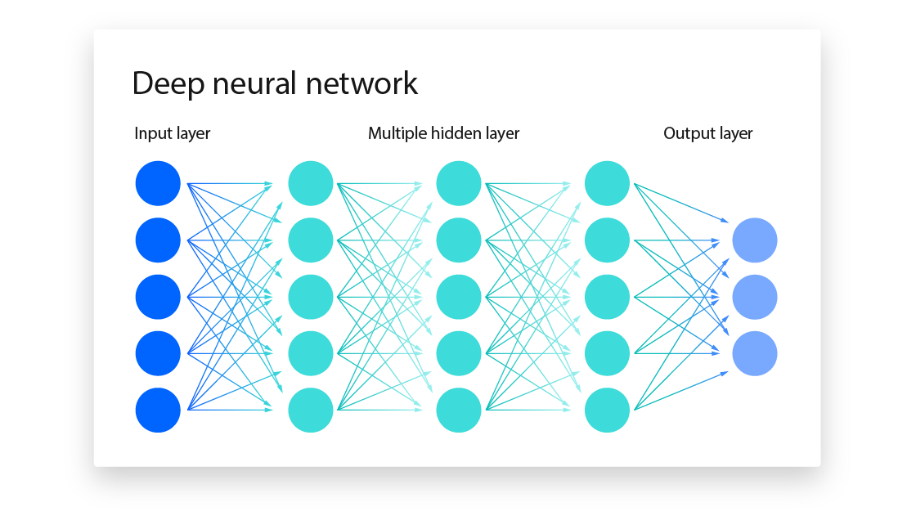

Applications

* Image classification
* Natural language processing
* financial forecasting
* Medical diagnosis
* Reinforcement learning

Reinforcement learning (RL) is an interdisciplinary area of machine learning and optimal control concerned with how an intelligent agent should take actions in a dynamic environment in order to maximize a reward signal.

Reinforcement learning is one of the three basic machine learning paradigms, alongside supervised learning and unsupervised learning.

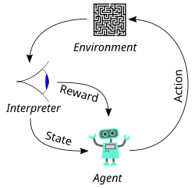

* Genetic algorithms

Genetic algorithms are defined as a type of computational optimization technique inspired by the principles of natural selection and genetics.

They are used to solve complex problems by mimicking the process of evolution to improve a population of potential solutions iteratively.

Genetic Algorithms(GAs) are adaptive heuristic search algorithms that belong to the larger part of evolutionary algorithms. Genetic algorithms are based on the ideas of natural selection and genetics. These are intelligent exploitation of random searches provided with historical data to direct the search into the region of better performance in solution space

**Genetic algorithms simulate the process of natural selection** which means those species that can adapt to changes in their environment can survive and reproduce and go to the next generation. In simple words, they simulate “survival of the fittest” among individuals of consecutive generations to solve a problem. **Each generation consists of a population of individuals** and each individual represents a point in search space and possible solution. Each individual is represented as a string of character/integer/float/bits. This string is analogous to the Chromosome.

